<!DOCTYPE html>

<html lang="en">

<head>

    <meta charset="UTF-8">

    <meta name="viewport" content="width=device-width, initial-scale=1.0">

    <title>CAT FACE</title>

    <link rel="stylesheet"href="style.css">

</head>

<body>

<div class="drawing-holder">

    <div class="cat-face">

        <div class="cat-eyes"></div>

        <div class="cat-nose"></div>

        <div class="cat-mouth"></div>

    </div>

</div>

</body>

</html>

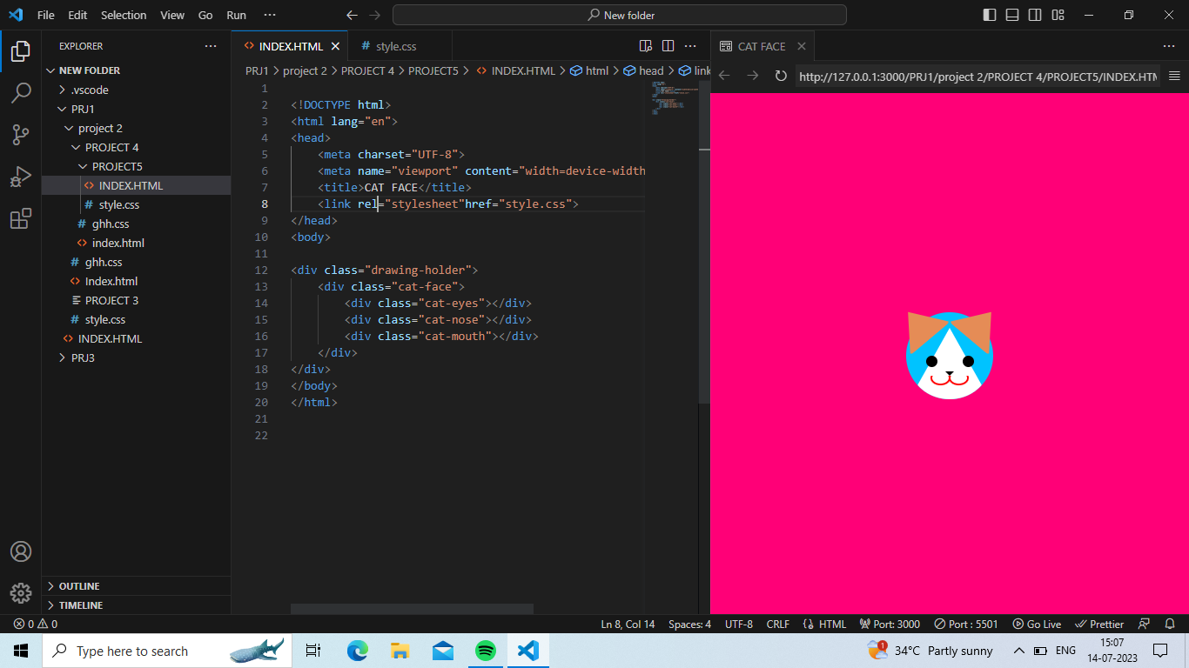

html{

background-color:rgb(255, 0, 119);

}

.drawing-holder{

width: 100px;

height: 100px;

position: absolute;

margin-top: -50px;

margin-left: -50px;

top: 50%;

left: 50%;

}

.cat-face{

background-color:rgb(0, 195, 255);

width: 100px;

height: 100px;

border-radius: 50%;

display: block;

position: relative;

float: left;

}

.cat-nose{

position: absolute;

bottom: 0;

z-index: 1;

left: 4px;

width: 0px;

height: 0px;

border-right: 46px solid transparent;

border-left: 46px solid transparent;

border-bottom: 82px solid #fff;

border-radius: 50%;

}

.cat-nose:after{

display: block;

content: "";

position: absolute;

top: 50px;

left: 50%;

margin-left: -5px;

width: 0;

height: 0;

border-right: 5px solid transparent;

border-left: 5px solid transparent;

border-top: 5px solid #000;

}

.cat-mouth{

width: 50px;

height: 11px;

position: absolute;

top: 73px;

left: 50%;

margin-left: -25px;

z-index: 2;

overflow: hidden;

}

.cat-mouth:before{

content: "";

display: block;

position: absolute;

left: 3px;

bottom: 0;

border: 2px solid red;

width: 19px;

height: 13px;

border-radius: 50%;

}

.cat-mouth:after{

content: "";

display: block;

position: absolute;

right: 3px;

bottom: 0;

border: 2px solid red;

width: 19px;

height: 13px;

border-radius: 50%;

}

.cat-eyes{

position: absolute;

top: 50px;

width: 55px;

left: 50%;

margin-left: -27px;

z-index: 2;

}

.cat-eyes:before{

position: absolute;

display: block;

content: "";

width: 13px;

height: 13px;

background-color: black;

left: 0;

top: 0;

border-radius: 50%;

}

.cat-eyes:after{

position: absolute;

display: block;

content: "";

width: 13px;

height: 13px;

background-color: black;

right: 0;

top: 0;

border-radius: 50%;

}

.cat-face:before{

position: absolute;

display: block;

content: "";

width: 0;

height: 0;

border-left: 30px solid transparent;

border-right: 30px solid transparent;

border-bottom: 40px solid #E58C56;

border-radius: 5px;

left: -15px;

top: -5px;

transform: rotate(-40deg);

}

.cat-face:after{

position: absolute;

display: block;

content: "";

width: 0;

height: 0;

border-left: 30px solid transparent;

border-right: 30px solid transparent;

border-bottom: 40px solid #E58C56;

border-radius: 5px;

right: -15px;

top: -5px;

transform: rotate(40deg);

}

